Space to Work: A Shared Cognitive Workspace for Human-AI Cyber Operations
Design concepts for a discovery-driven environment digital twin and collaborative reasoning
Nathan Conklin
nathan.conklin@vt.edu
Department of Computer Science,
Virginia Tech

Overview
Cyber analysts and operators work across many tools and hold most of the operational picture in their heads. This document describes a single workspace where a human and an AI partner build that picture together and keep it visible. The workspace centers on one object, the operation, and represents its hosts, evidence, hypotheses, attack paths, and decisions in one shared, manipulable space.
The system rests on two design commitments. First, all content lives in one graph with many node types, so a cyber kill chain and a chain of reasoning are the same kind of artifact. Second, arranging that graph in space carries meaning; moving, grouping, and linking objects changes how the AI reasons rather than serving as passive note-taking.

One Graph for Reasoning and Cyber
Human reasoning and cyber analysis reduce to the same underlying structure: a set of entities and relationships that evolves as evidence arrives. Instead of maintaining a separate reasoning graph and cyber graph, the workspace uses one graph whose nodes carry different types.
The ontology spans several categories:
- Reasoning: goal, question, assumption, hypothesis, evidence, decision, recommendation.
- Knowledge: document, fact, observation, source, citation.
- Cyber: host, user, credential, process, service, registry key, vulnerability, CVE, ATT&CK technique, IOC, asset, mission.
- Planning: action, agent, tool, simulation, alternative, plan.
- Interaction: annotation, discussion, cluster, human insight.
Under this model the cyber kill chain is one specialized view of the graph. A kill-chain stage such as Persistence is a node that gathers its supporting evidence (a process-creation event, Windows Event ID 4688; a registry modification; a scheduled task), a competing hypothesis (a legitimate software update), and a confidence value. Stages connect to earlier and later stages, but the connections branch and converge rather than forming a straight line, because evidence often supports several stages at once.
One graph means the visualization and interaction techniques built for reasoning apply to cyber work without modification. Decision focus, confidence scrubbing, reasoning lenses, and concept synthesis all operate on the same nodes; only the vocabulary of node types grows.

Space as an Active Substrate
Position and grouping carry semantic weight in this workspace. The arrangement of objects is an input to the AI's reasoning rather than a passive layout. Spatial actions map to defined changes in the model:
- Moving two hypotheses closer together raises the AI's estimate that they are related.
- Moving evidence away from a hypothesis weakens its support.
- Circling a set of objects creates a new abstraction over them.
- Collapsing a cluster tells the planner to treat it as a single concept.
- Splitting a cluster creates an alternative world model to reason about in parallel.
Grouping, linking, filtering, and annotation become operations with measurable effects on machine reasoning. The analyst reorganizes the space to think through the problem, and the AI updates its model in response.

Four Generations of the Workspace
The system holds the cyber domain constant and varies the interaction paradigm. This produces four generations of one workspace rather than four unrelated interfaces, with a through-line from conversation to operation.
- Generation A, Cyber Assistant. A conversational interface. The analyst asks questions and the AI answers; the interaction is a dialogue.
- Generation B, Reasoning Workspace. A structured reasoning surface. Hypotheses, evidence, and confidence appear as navigable nodes rather than as chat turns.
- Generation C, Collaborative Investigation. A shared canvas for cyber investigations. Evidence objects, ATT&CK techniques, host timelines, and hypotheses sit in space, connected by semantic links, with the AI suggesting connections as the analyst arranges the material.
- Generation D, Cognitive Operations. An agentic environment. AI agents propose tests, gather data, and update the workspace while the human remains the decision maker.
The progression, conversation to reasoning to investigation to operation, gives the system a single design narrative.

From Investigation to Operation
When the workspace supports active testing rather than only analysis, the central object changes from an investigation to an operation, or campaign. Supporting an operation calls for a few components:
- A mission definition holding objectives, rules of engagement, target scope, and success criteria.
- An operational graph showing discovered assets, trust relationships, vulnerabilities, and active hypotheses about attack paths.
- An AI planner that proposes candidate attack paths, each with an estimated success likelihood, potential impact, and effort, and leaves the choice to the human.
- Execution that runs only inside an approved test environment and under explicit authorization, with the workspace coordinating tools rather than the operator switching between them.
The research emphasis stays on the interaction model, on how a human and an AI co-manage a complex operation, rather than on autonomous penetration. That keeps the contribution in human-computer interaction while retaining serious technical grounding.

System Layers
Five layers describe the system. Not all of them are interface surfaces; some are system concerns that can live outside the workspace.
Layer | Role | Interface surface
Mission and Governance | Objectives, constraints, permissions | No; lives in a brief or config file
Environment Digital Twin | The target model, discovered and refined over time | Yes; rendered inside the shared workspace
Operational Planning | Hypotheses, alternative paths, mission modeling | Yes; folded into the shared workspace as in-context behavior
Execution Orchestration | Runs approved tests and gathers data through controlled interfaces | Minimal, abstract controls
Shared Cognitive Workspace | The human-AI teaming surface where state and reasoning are visible and steerable | Yes; the primary interface

Governance stays out of the main interface. In a research or lab setting it records intent and boundaries: what the experiment is trying to learn, what success means, and which actions are permitted. That belongs in a brief or a configuration file rather than a panel.
Planning is a behavior of the shared workspace rather than a separate panel. The analyst spawns alternative hypotheses or paths in place, compares them side by side, collapses or annotates them, and the AI reacts. A prompt describing the shared workspace should state that planning happens in context: branching hypotheses, side-by-side options, visible assumptions and confidence, with the AI suggesting but not enforcing paths.
Execution controls stay minimal and abstract. The operator states intent, and the system coordinates the tools behind approved boundaries.
The two core interface surfaces are the shared workspace and its in-context planning, with the environment digital twin rendered inside them.

The Environment Digital Twin
The signature concept is a living model of the target environment that the tool discovers as it works. The workspace starts nearly empty and builds the twin as discovery proceeds; the topology is the target environment rather than the interface, and the tool does not pre-draw it.
A representative target shows the range the tool must handle. An external boundary point connects to outside communications and fronts a small operations enclave of roughly eight nodes. A cross-domain solution bridges that enclave to a higher-security enclave, such as a secret or TS/SCI network. Inside the secure enclave, a hub-and-spoke architecture routes traffic across roughly one hundred switches and five hundred nodes.
The interface treats this as a hierarchy of digital twins. At the top level it shows three blocks: external, operations enclave, and secure enclave. Zooming into the secure side reveals domains, then services, then individual assets, so the operator never faces five hundred nodes at once. The view toggles between logical and physical representations, data flows, and trust relationships, and the AI runs parallel analyses, attack-path hypotheses, patch-impact estimates, and alternative plans, as overlays rather than walls of text. A time slider replays the campaign from the beginning.
The tool builds the model through discovery. The first screen is skeletal. As the tool discovers the first external node, that node appears; the tool adds relationships as it learns more. The cross-domain boundary appears as a constraint in the model, and the tool reveals the secure enclave gradually. The twin is an evolving artifact, closer to mapping a dungeon as you move through it than to reading a fixed network diagram.
Uncertainty is explicit. Unknown regions are first-class objects rather than blank space. The AI marks a region as a hypothesis, for example a zone it judges likely to contain a given class of assets, and attaches a confidence value. Its job is to track what is known, suspected, and ruled out, and to propose safe probes that reduce the unknowns. This framing keeps the tool a workspace for human-AI collaboration rather than an autonomous attack system.

Human-AI Teaming and Oversight
Across all four generations, the human is the decision maker and the AI is a teammate that proposes. The AI watches the work, surfaces observations (three pieces of evidence that point to credential theft; a resemblance to a prior incident), and offers to act (construct a probable kill chain; generate ATT&CK mappings; run a safe probe). Each offer is a proposal the analyst accepts, edits, or rejects. Execution follows only after approval and only within authorized boundaries. This proposal-before-execution pattern keeps the operator in control of an operation that a set of agents helps carry out.

Interface Concept Prompts
The prompts below generate visual mockups of the workspace with an image model such as GPT Image or Midjourney. Each targets one of the concepts described above.
Mission View. "Design a futuristic but realistic cybersecurity operations workspace called 'Cyber Collaborative Workspace, Mission View.' A 32-inch ultrawide enterprise UI, dark theme, accessible. Center shows a live mission dashboard with objectives, rules of engagement, status, and progress. Left sidebar for mission hierarchy and targets. Right panel with an AI operations partner explaining suggestions and requesting approvals. Bottom timeline of events and decisions. Clean, professional aesthetic with subtle animations, inspired by Figma, Bloomberg, and Palantir."
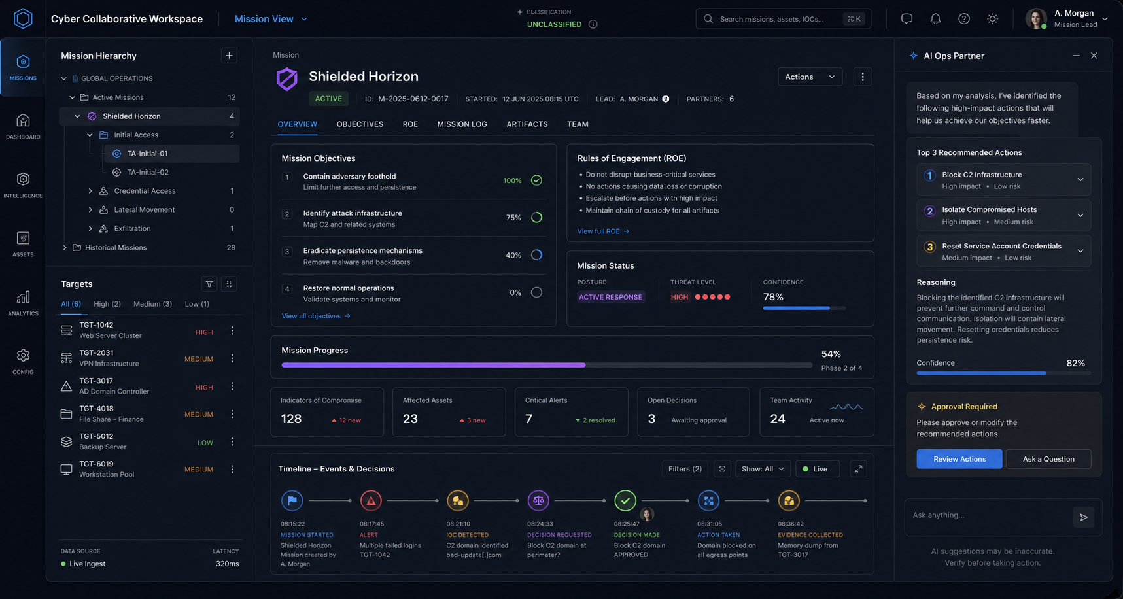

Operational Graph. "Create a collaborative operational graph workspace. The center is an interactive graph of hosts, identities, services, vulnerabilities, and trust links, colored by status, with AI-suggested attack paths shown as highlighted routes. The left panel shows filters and evidence collections. The right panel shows reasoning, hypotheses, and recommended next steps with confidence and provenance. Sleek, minimal, highly interactive, 16:9."
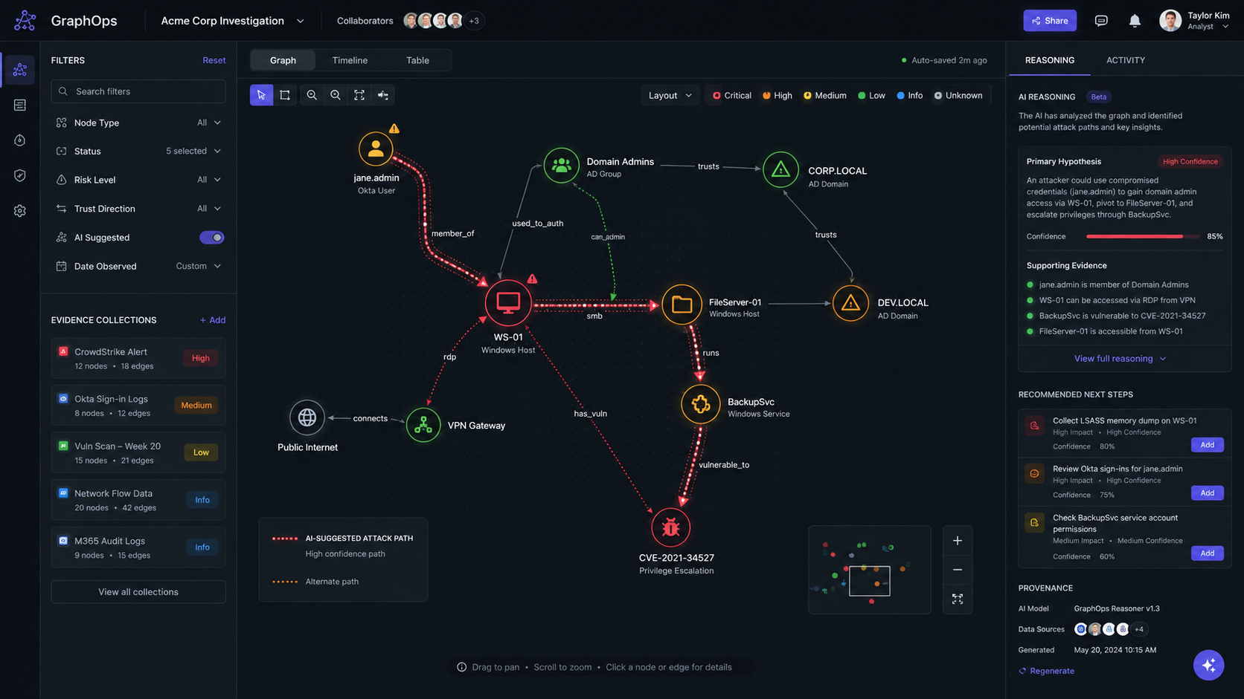
Space to Work. "Design a collaborative cognitive workspace for cyber operations called 'Space to Work.' A freeform canvas holds spatially arranged evidence objects, notes, ATT&CK techniques, and hypotheses connected by semantic links. Coordinated views surround it: graph, timeline, and evidence table, with an AI teammate suggesting connections without interrupting. The feel is Figma combined with a security operations center: clean, dense, elegant."
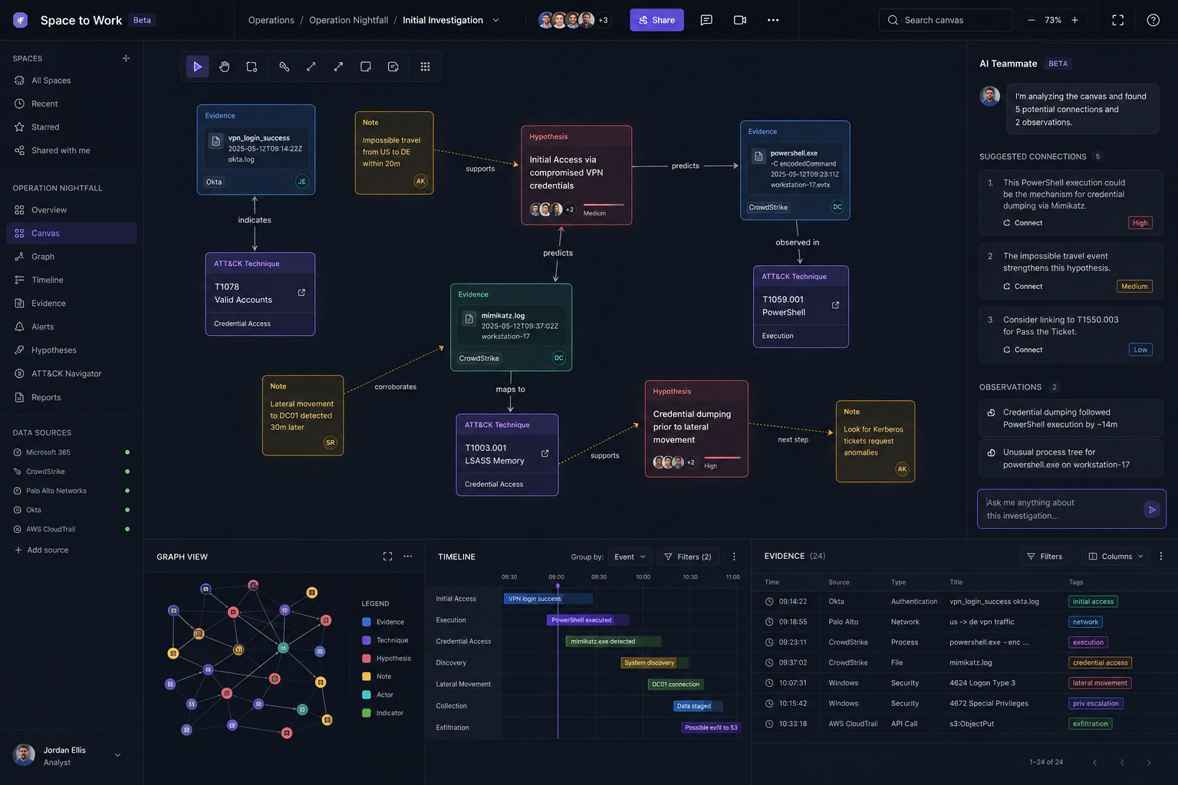
Cognitive Operations. "Create a futuristic cognitive operations workspace showing a human overseeing a team of AI agents. The center is the current campaign state. The left is a roster of AI specialists with tasks and confidence. The right is a decision panel with recommended actions, rationale, and mission-impact estimates. The top shows mission objectives; the bottom shows execution progress and system health. High-end enterprise look, realistic rather than science fiction, emphasizing clarity and human control, 16:9."
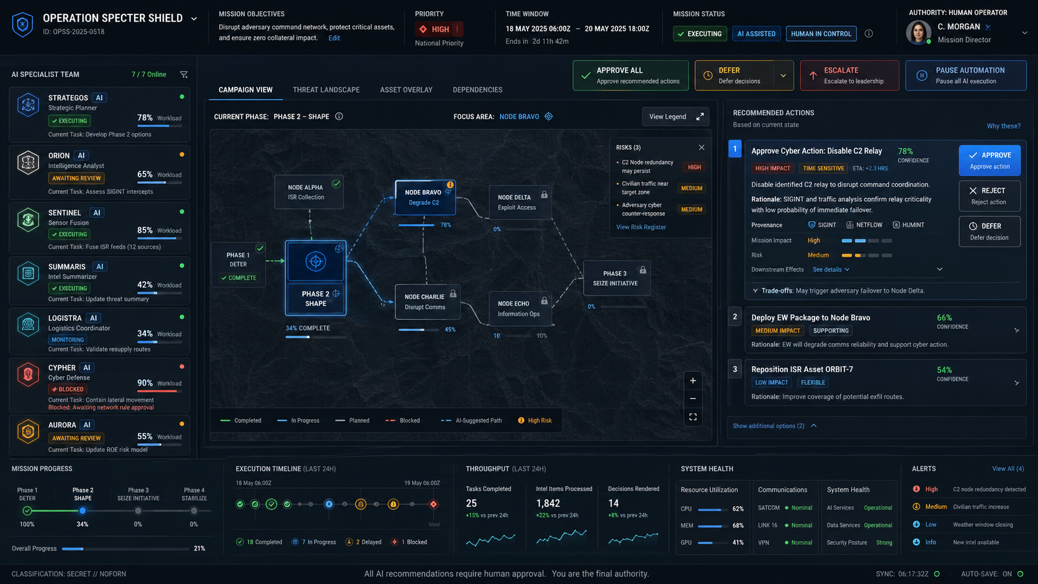
Cyber Operations Digital Twin. "Design a Cyber Operations Digital Twin workspace where the enterprise is visualized as a living model. The center shows a layered 2.5D model of an organization's infrastructure, networks, cloud, identities, and services, with AI agents represented as active collaborators moving through the model. Each asset is clickable to reveal state, history, related evidence, and suggested actions. The left panel shows mission and constraints; the right panel shows AI reasoning, alternative paths, and what-if scenarios. The bottom shows a time slider for replaying the campaign. High information density with clear hierarchy, realistic product design, 16:9."
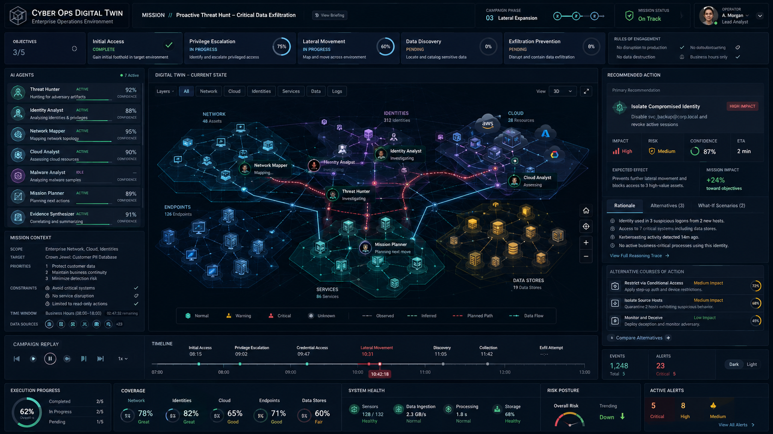

Summary
The system is one workspace in which a human and an AI share a persistent, manipulable model of a cyber operation. The kill chain, the reasoning behind it, and the environment it targets all live in a single graph, arranged in a space where position carries meaning. The interface progresses from a cyber assistant to a cognitive operations environment while holding the cyber domain constant. Governance and execution stay thin; the shared workspace and its in-context planning carry the interaction, with the environment digital twin discovered and refined as the operation proceeds. The human decides; the AI proposes and executes within approved boundaries.

